

|  |
| --- |
| **Master of Research Study**  **People with Intellectual**  **Disabilities and Social Media Use**  **Interview Participant Information Sheet** |
|  |

**About our study**

|  |  |
| --- | --- |
| USY_MB1_RGB_1_Colour_Standard_Logo.tif | The University of Sydney is doing a research study on how people with  Intellectual disabilities use social media. |
|  | We want to find out how social media helps you talk to others and show who you are. |
|  | We want to find out what you like and don’t like when using social media. |
|  | This study will start in 2024 and finish in 2026. |

|  |  |
| --- | --- |
|  | As part of the research study, we want to talk to people with intellectual disabilities. |
|  | We want people with intellectual disabilities to tell us about their experiences online and what is important to them. |
|  | We will also do this by having  interviews asking people about their experiences on social media. |
|  | We will ask you questions about   * How you use social media. * Why you use social media. * Any challenges or benefits   you experience on social media. |

|  |  |
| --- | --- |
|  | In the interview, we will ask you to show talk and share some of your own social media posts and comments.  You will be sent a link before the start of the interview to share your social media posts and comments with us. |

**What you have to do to**

|  |  |
| --- | --- |
|  | If you choose to be part of the study we will send you a consent form. |
|  | You will need to print this form if you are signing the consent form using a pen. |

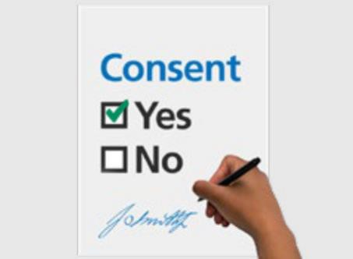You need to fill in and sign the consent form and email it back to [ryandavid.andriesz@sydney.edu.au](mailto:ryandavid.andriesz@sydney.edu.au) if you are doing it online.

|  |  |
| --- | --- |
|  | **The consent form** says that you   * Understand what the research study is about. * Want to be part of it. * Are willing to show and share some of your own posts and   comments. |

|  |  |
| --- | --- |
|  | You will need to bring a **Phone**, **Tablet**, **Laptop** or **IPAD** to the interview. |
|  | Next we will get in touch with you to set a time to meet. |
|  | When we meet with you, we will do an interview together. |

|  |  |
| --- | --- |
|  | There will be questions about   * Your life. * Your choices. * Your supports. |

|  |  |
| --- | --- |
|  | Doing the interview together will take 25 to 30 minutes. |

**Who can be part of the research study**

|  |  |
| --- | --- |
|  | To be part of the study you must   * be an adult with intellectual disabilities. |
|  | You must be over the age of 18 years old to be a part of the study. |

**If you change your mind**

|  |  |
| --- | --- |
|  | You can decide if you would like to be a part of the research study. |
| USY_MB1_RGB_1_Colour_Standard_Logo.tif | No one will be upset with you if you do not take part. |
|  | You can decide if you do not want to be a part of the study at any time. |
|  | If you decide that you do not want to be a part of the study during the  interview you can let us know. |

**Support**

|  |  |
| --- | --- |
|  | We will help you get support if something about the research study makes you feel upset. |
|  | You can tell us if there is something about the research study that you are not happy about. |

**After the study**

|  |  |
| --- | --- |
|  | The study will help us understand how to make social media better for people with intellectual disabilities. |

We will share the results with you in an easy read report when the research project is finished is you wish.

To find out more about this study you can contact the research team at the University of Sydney.

You can email student researcher, Ryan David Andriesz or lead supervisor, Dr Catherine Jeffery.

* [Ryandavid.andriesz@sydney.edu.au](mailto:Ryandavid.andriesz@sydney.edu.au)
* [catherine.pagejeffery@sydney.edu.a](mailto:catherine.pagejeffery@sydney.edu.au) [u](mailto:catherine.pagejeffery@sydney.edu.au)